Hexaflexagons

What is a Hexaflexagon?
A hexaflexagon is a 6 sided polygon that has numerous properties to it rather than its initial two faces. Through the art of flexing, we can reveal alternate faces of the hexagon.

Why is it relevant today?
Arthur H. Stone, illeged discoverer of the Hexaflexagon, began folding his trimmings of paper and folded it into a flexagon. He formed the flexagon committee with his friends from Princeton University and began unfolding its properties. Through publications of this theory over the years, the structure gained traction and we observe many mathematicians and teachers educating others about these concepts.

Mathematics behind Hexaflexagons:

Moebius Strip
The Moebius Strip is a twisted cylinder that contains non-oriental properties, in which the twist is independent of the strip of paper. The Moebius Stip is non-oriental because the flow of the structure is in multiple directions.
Tuckerman’s Traverse and Feynman’s Diagram
Tuckerman's Traverse states that if you keep pinching two sides of the flexagon together until you can’t move it anymore, move on to the next side to create a flex. All you have to do is rotate the flexagon 60 degrees and it will open up again. The Feynman Diagram shows this effect visually.
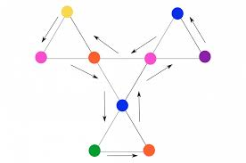

Catalan Numbers
Catalan numbers are a sequence of numbers derived using Cn = (2n)! / ((n + 1)!n!). In terms of flexagons, we can use these numbers to figure out how many flexes there are.

C0:_____ C1:_____ C2:_____ C3:_____ C4:_____ C5:_____
For example, in a flexagon that contains three colors, the third Catalan number, C2 or 2, represents the fact there are two possible flexes in the structure.

Constructing Hexaflexagons:

- First start off by acquiring a template. You can use the one I offered in the worksheet. Cut the template out precisely.
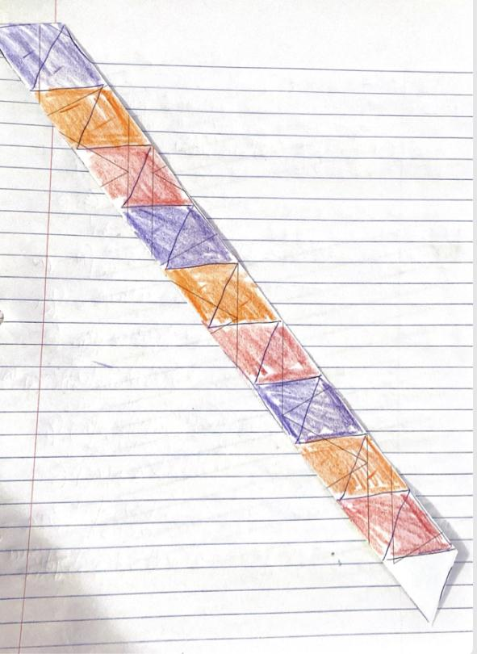
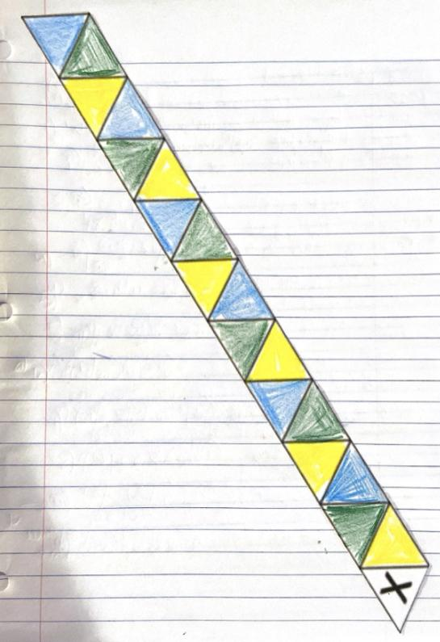
- Color in the triangles with a 123123 pattern on one side and 445566 on the other. Make sure the white tips remain white on opposite ends of the template.

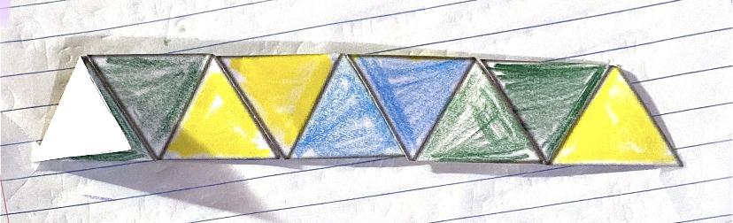
- Next, we want to fold each triangle so it is compressed into one triangle at a point. Once folded, open it up and spiral the triangles until you have a trapezoidal shape like the one below.

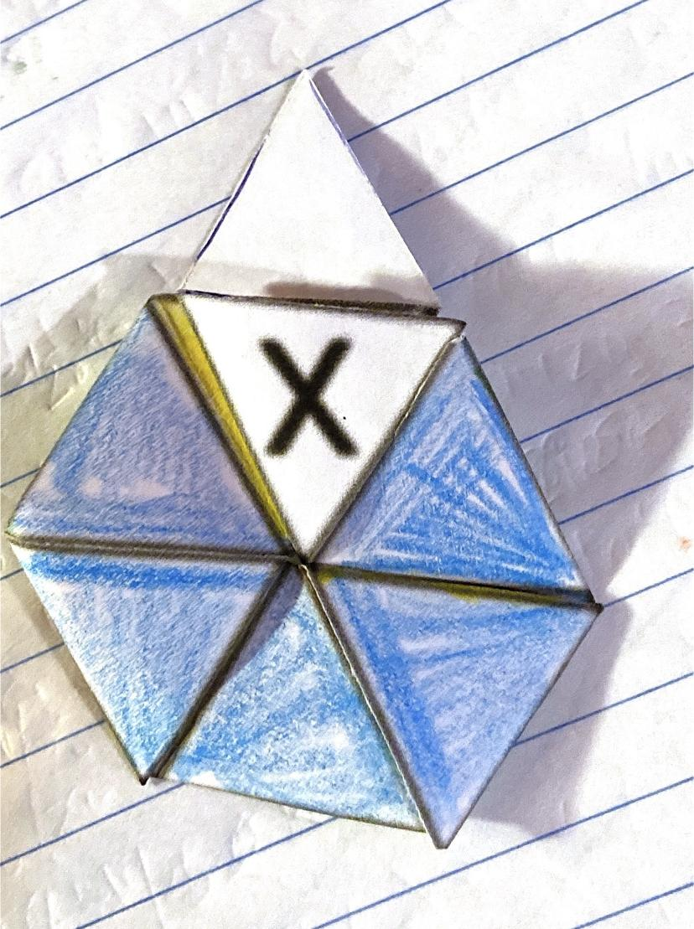
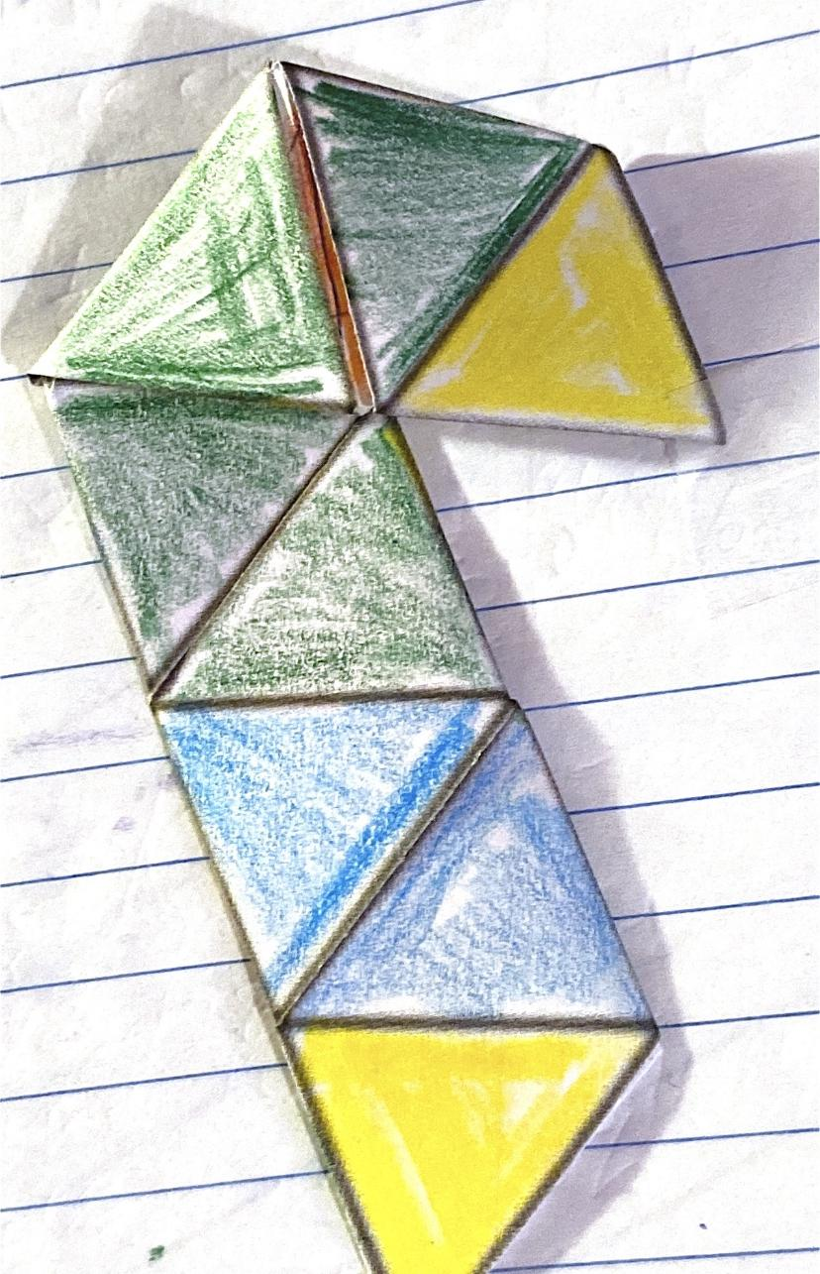
- Now let’s start formating the hexagon aspect of the hexaflexagon. We start by folding counter clockwise on every third hinge. This will reveal all of one color on one side. Lastly, we match up the white strips and tape them together. You should now have a hexagon with two colors.
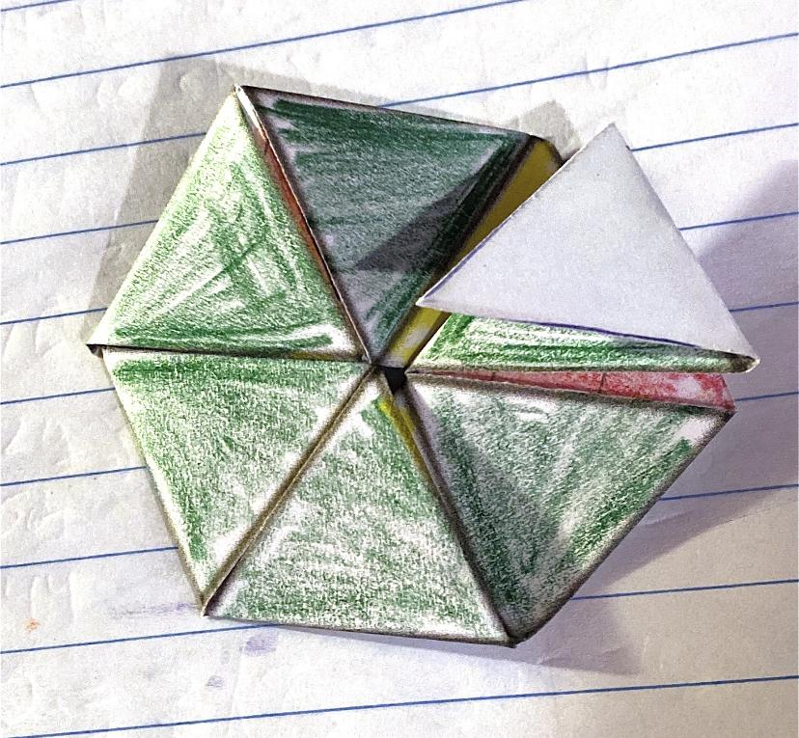
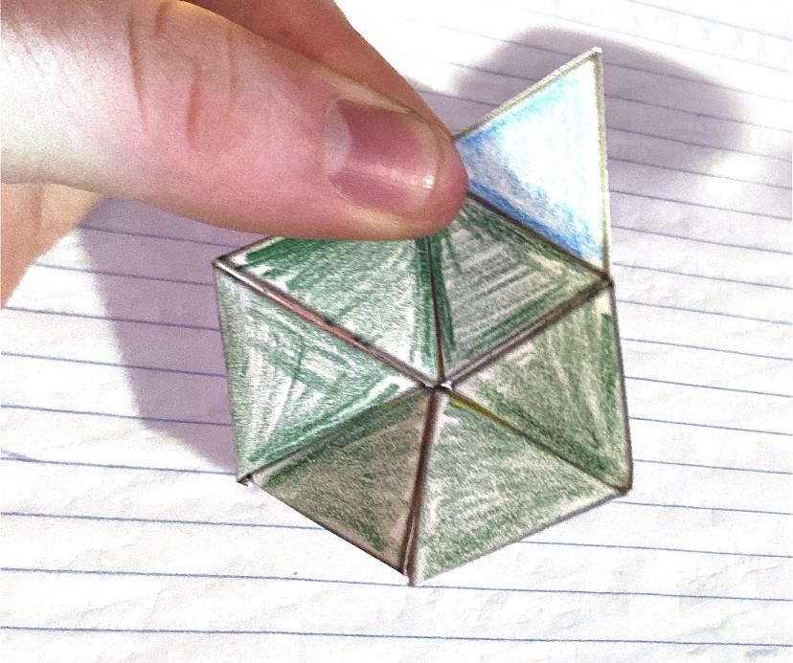

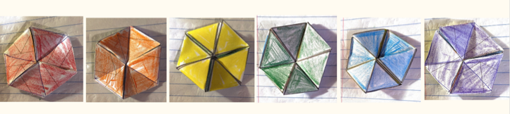
- Now flex!! See if you can reveal all of the colors. Start by pinching two sides together, then pinch the rest and flex. If the flex doesn’t perform, go back to the Tuckerman Traverse and move onto the next side (move in a direction of 60 degrees).

